

**SAP: Purchasing Cycles**

Assignment 3

INFO 3240

November 10, 2017

LiWen Tan

1. **Default Parameter ID**

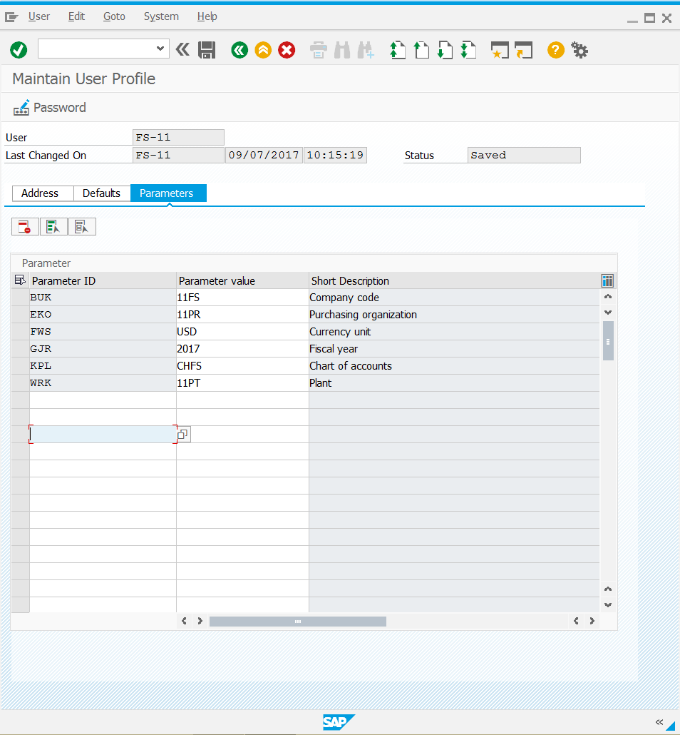

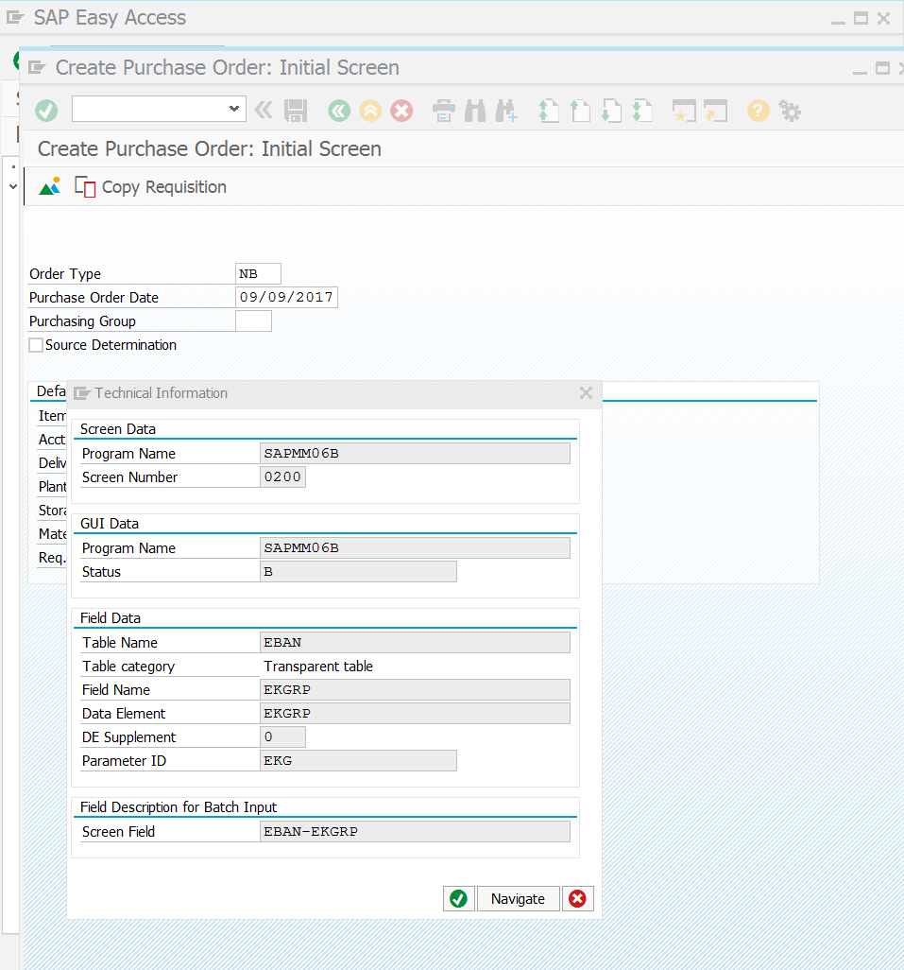

1. **Create Purchase Requisition**

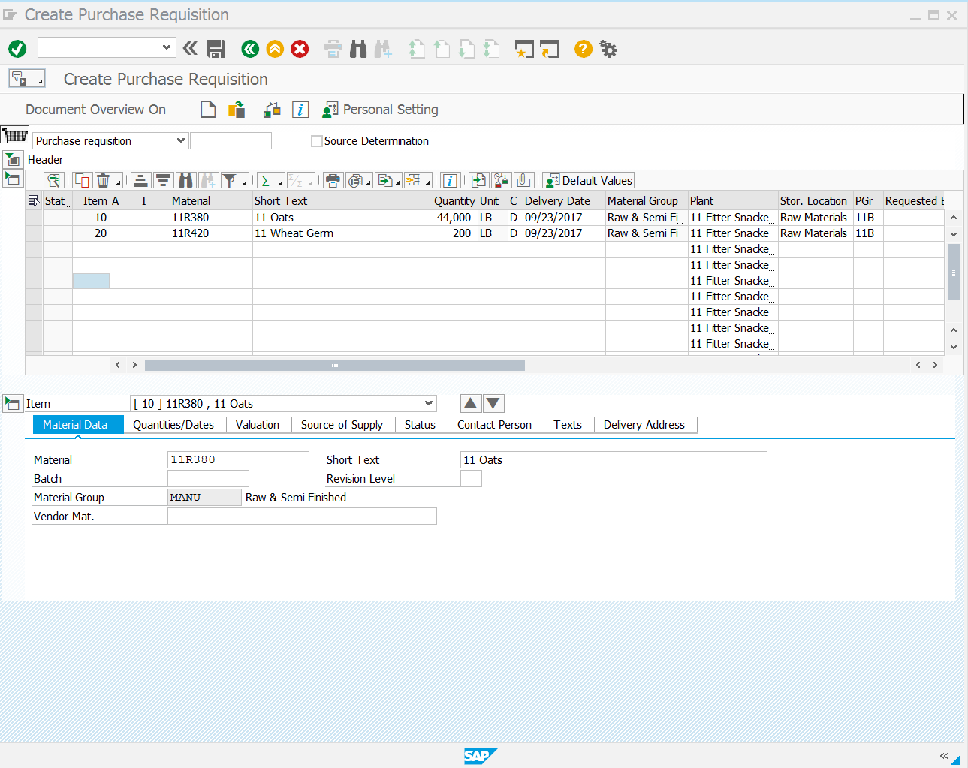

1. **Create Purchase Order from Requisition**

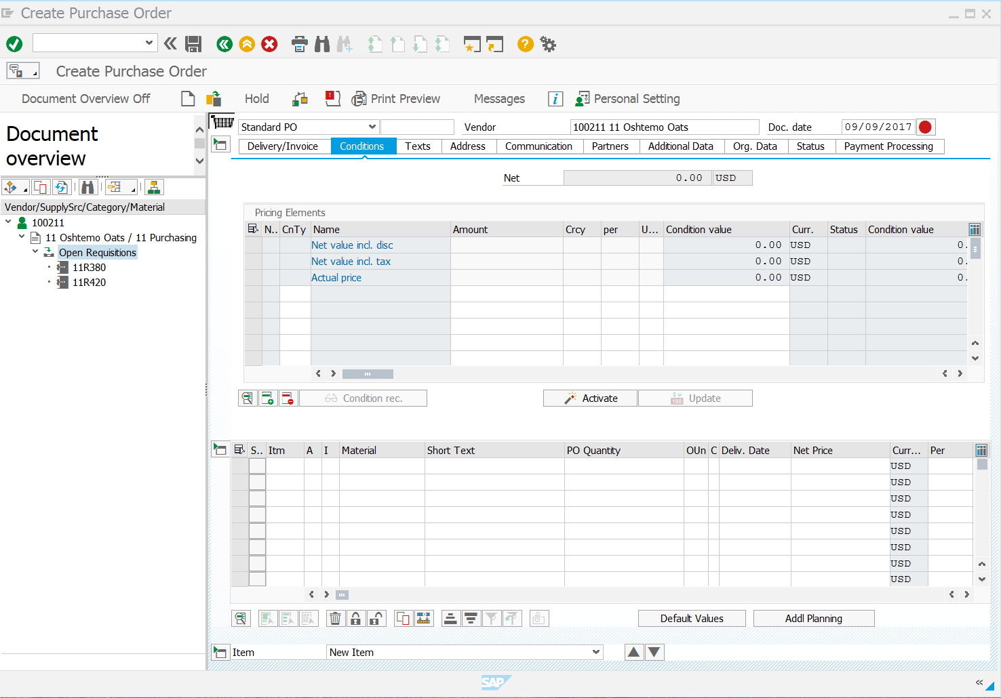

1. **Create a Goods Receipt**

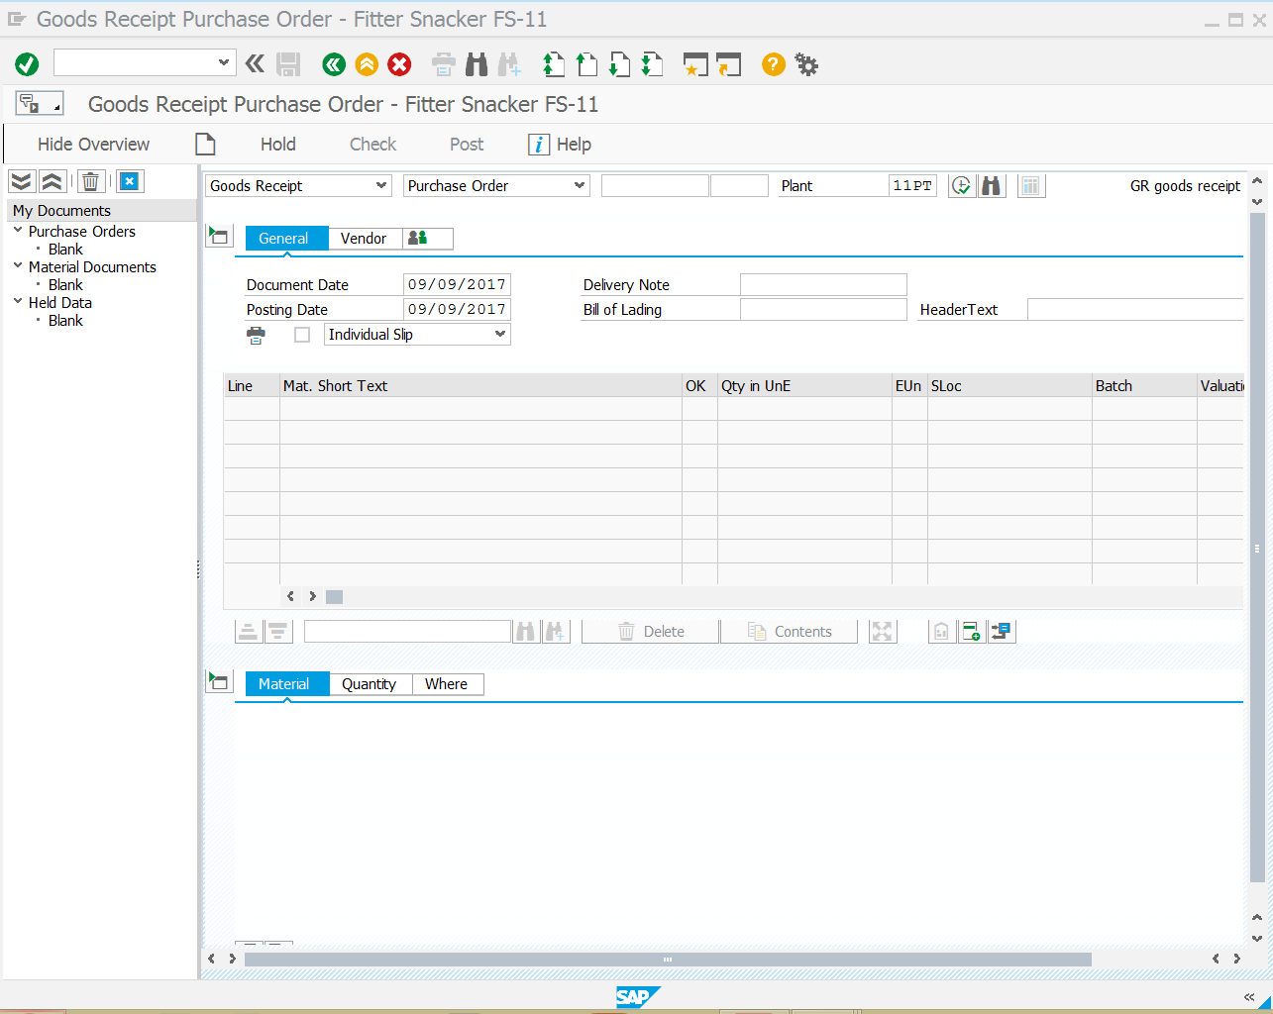

1. **Verify Material Receipt**

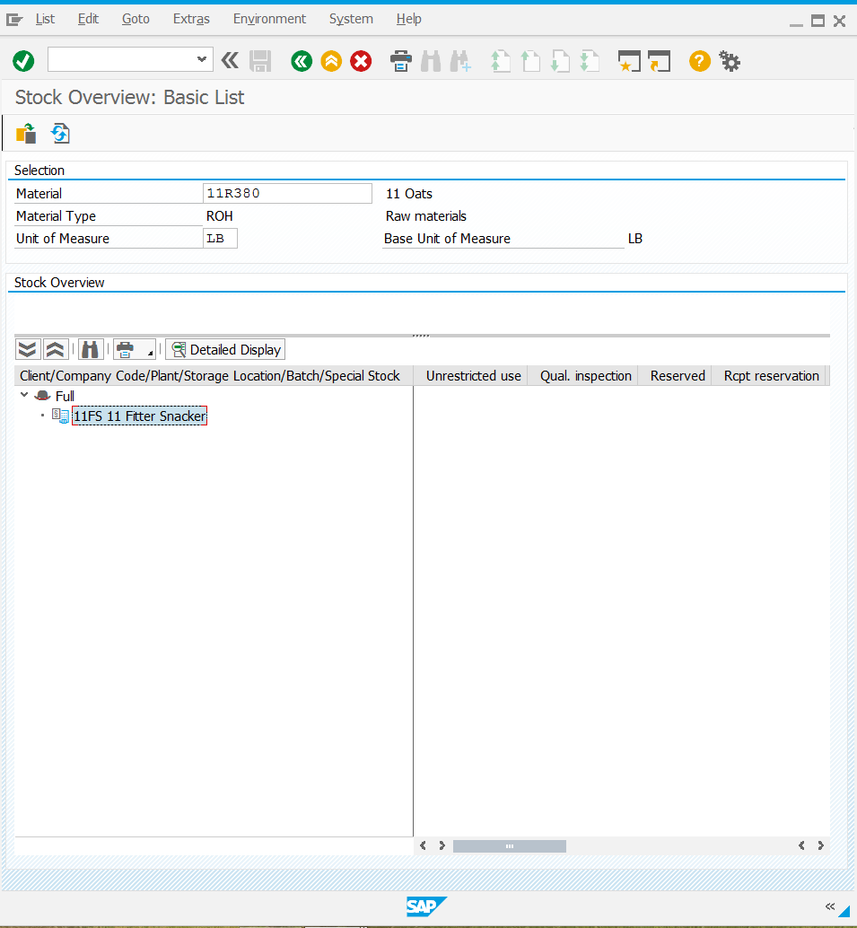

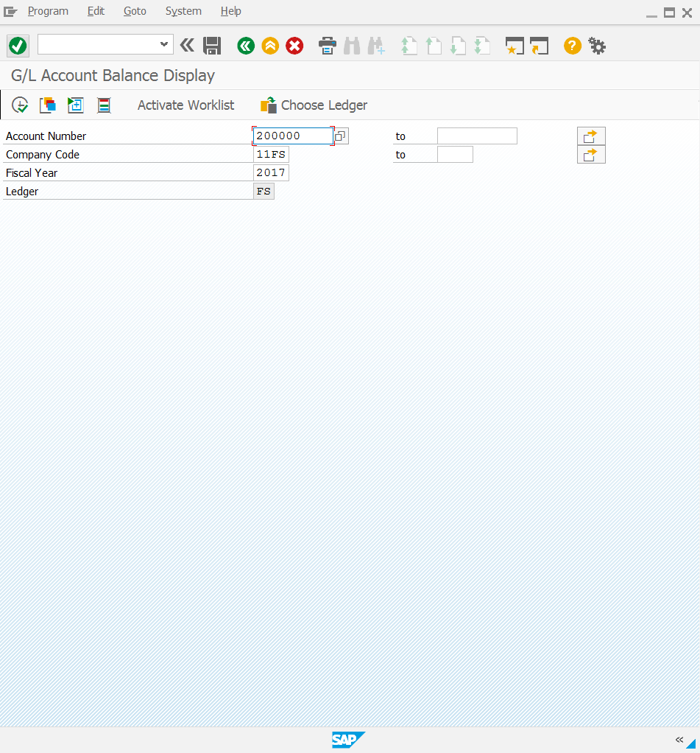

1. **Create an Invoice Receipt**

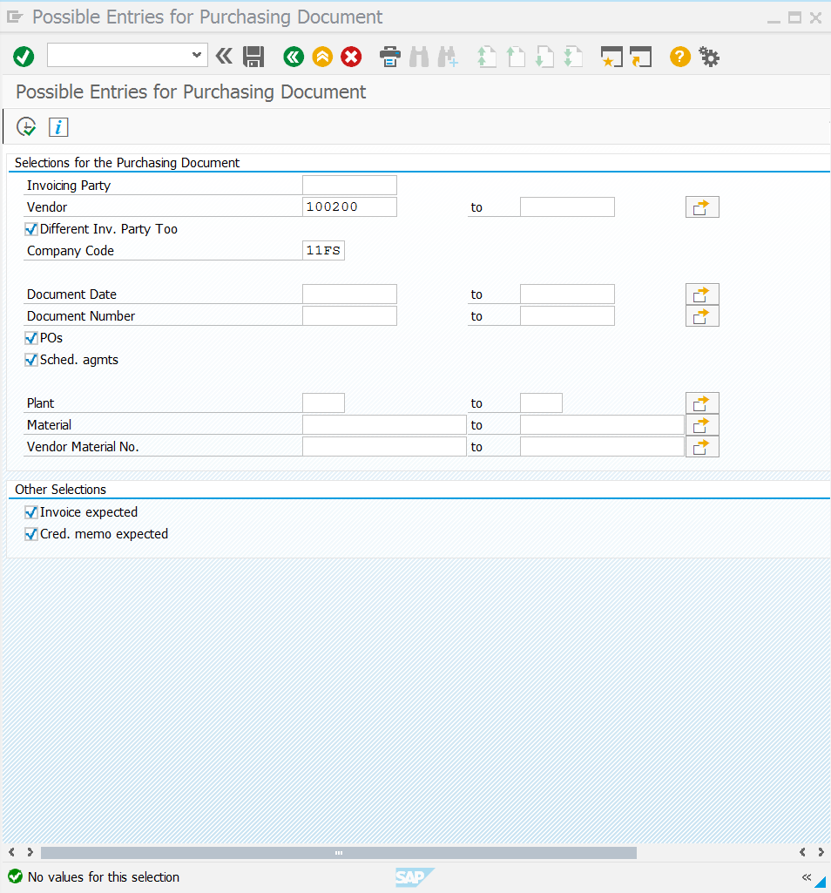

1. **Post outgoing payment**

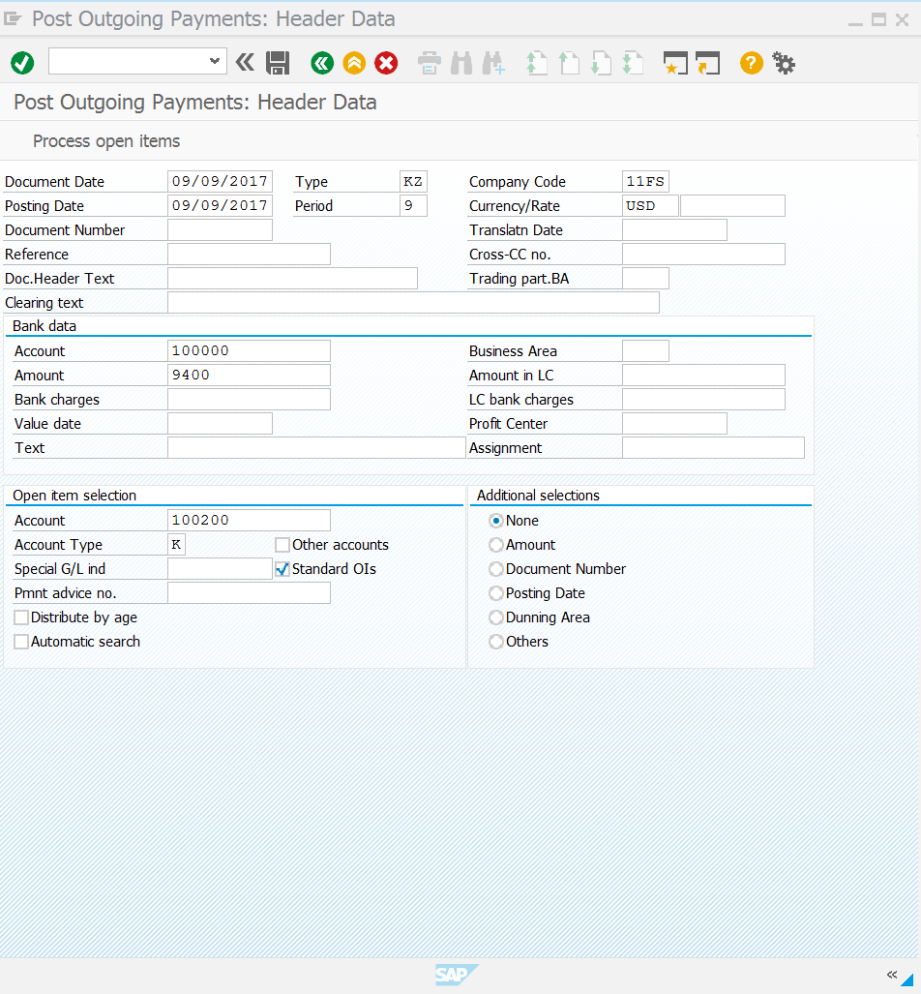

**8. Document outgoing payment**

